A Process for New Program Development
Tim Crowley, Associate Provost for Academic Affairs
February 2018
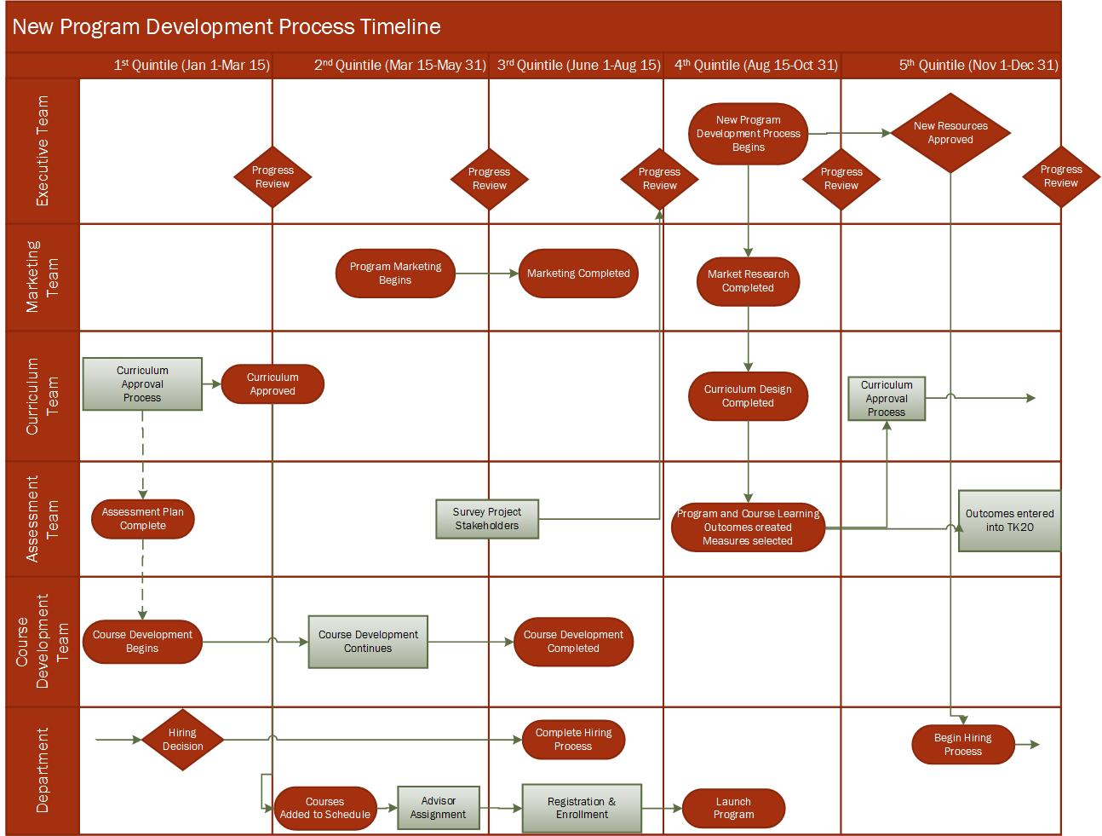
Introduction
Institutions struggle to develop processes to develop new academic programming in a timely manner. This proposal attempts to solve the following common challenges faced by Academic Affairs administrators, faculty, and staff:
1) Focus - coordinating work in a cross-divisional manner using teams, as opposed to the traditional hierarchical department-college-provost model. The rationale here is that a synergistic team in a specialized area can bring more expertise than faculty in departments whose primary function is teaching and learning rather than new program development. Organizational gaps can be managed more efficiently without having to train faculty and staff in each college/department with the expertise needed to launch a new academic program.
2) Improving Program Launch Time – today’s institutions must navigate their internal shared governance structures and office silos to launch programs in a timely manner before windows of opportunities disappear. The traditional semester calendar can be divided into frames more closely resembling quarters in the corporate world. The suggestion here is to utilize 10-week quintiles that roughly mirror the 8-week divisions of the academic calendar. The target quintile is always the fourth quintile, which aligns with the beginning of the Fall semester. With quintile deadlines, teams can accomplish assigned tasks within the rhythm of the academic year when faculty are present without becoming exhausted with multi-year projects.
3) Project Management – this process proposes the creation of a project executive team with responsibility for reviewing progress toward the launch of the new program and removing barriers to the success of the project along the way. An additional benefit of an executive team is communication among the divisional administrators in order to continue to support the program effectively post-launch. Quintile progress reviews are envisioned at the beginning of each quintile during the academic year – always with a fourth quintile goal for program launch in mind.
Team Composition
1) Executive Team - members of the executive team would include the Provost (chair), appropriate dean, appropriate department chair, and each of the four component team leaders (marketing, curriculum, assessment, and course development).
2) Marketing Team – members of the marketing team would include the Enrollment Management leader (chair), online programs director (if an online program), marketing specialist (if appropriate), university marketing director, and academic marketing specialist.
3) Curriculum Team – members of the curriculum team would include the Associate Provost (chair), appropriate dean, graduate dean (if graduate program), department chair, Faculty Senate Academic Affairs Committee Chair, and program faculty.
4) Assessment Team – members of the assessment team would include the institutional effectiveness leader (chair), assistant dean or college assessment coordinator, department chair, and program faculty.
5) Course Development Team – members of the course development team would include the teaching and learning center director, instructional designer, video specialist, department chair, and program faculty.
6) Department – the department where the program will be housed will be represented on all teams.

Team Responsibilities
1) Executive Team – Coordinates and communicates among all teams and the department involved in the launch of new academic programs. Secures new resources required early in the project. Reviews progress toward project milestones at each quintile start date. Reviews annual survey to inform process improvements.
2) Marketing Team – conducts market research on employment trends and interviews advisory stakeholder groups (if available). After the program curriculum has been approved, launches marketing campaign until project launch (2nd and 3rd quintiles).
3) Curriculum Team – designs program curriculum in alignment with the board and institutional standards and program faculty vision. After assessment team develops learning outcomes, the curriculum team shepherds curriculum through internal governance processes and board approval process, if necessary. Updates catalog, board program inventory, Registrar’s degree list, and creates advising degree summaries.
4) Assessment Team – designs appropriate program and course learning outcomes, makes decisions on appropriate measures and thresholds, and prepares assessment management software for collection of assessment data. Surveys all stakeholders in the new program development process at the beginning of the 3rd quintile. Analyzes responses to survey and shares with Executive Team to inform process improvements.
5) Course Development Team - designs and assists program faculty in designing courses for delivery at a distance. Assures course quality and compliance with accessibility and other requirements.
6) Department - the department chair will have responsibilities for: (1) hiring qualified new faculty to deliver the program, (2) creating the course schedule to allow for registration and enrollment prior to launch, and (3) ensuring adequate advising is in place to support the program.

